December GATE Group: “Being Bucket Fillers” “Be Kind”
Our December GATE Group session was about “Being Bucket Fillers” which is simply, “Being Kind”!!
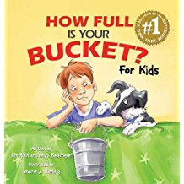
I read a book to the group called: “How Full is Your Bucket?” We discussed all the ways that your children have had their buckets filled by others, and how they have filled others’ buckets.

After this discussion time, I handed out the “Be Kind Always” mini posters that you see below. Each student needed to complete the 10 tear-off slips on the bottom of the poster with ideas on how they could make others “feel” their kindness. The slips could have positive comments on them or they could just remind your child what they wanted to do
to” fill up” another person with their kindness.
These mini posters will be placed in your children’s lockers, so after the holiday break, they will be reminded to build others up after vacation.

